Funeral Planning Guide for Families

“The Lord is near to the brokenhearted,
and saves the crushed in spirit.”
Psalm 34:18

Thank you for considering St. Norbert’s for your loved one’s funeral. Our team will support you in planning a beautiful and meaningful celebration of their life.
To support your planning, you’ll have 3 conversations with our staff:
- Ann, Executive Assistant to Fr. Steve, about scheduling the funeral (you may have already done this).
- Father, to discuss the readings and the liturgy (Ann or Father will contact you to schedule).
- Charlie, Director of Worship, for additional details and questions. (He will call you after your meeting with Father).
Please review this Planning Guide in advance of your meetings with Father & Charlie.
If you have any questions or concerns along the way, feel free to contact Charlie Bates, Director of Worship, at cbates@parish.stnorbert.org or by call/text at (484) 321-3819.

Contents
Meeting with Father 3
Bible/Scripture readings 3
Review Prayers of the Faithful/Intercessions 3
Readers 4
Gift Bearers 4
Eulogies & Words of Remembrance 4
Meeting with Charlie 6
Music 6
Payments - without a funeral home 7
Urn set-up 8
Flowers 8
Livestreaming and Recording 9
Pictures, video and memorabilia 10

Meeting with Father

Bible/Scripture readings

At a Catholic funeral, there are 3 readings from the Bible: generally one from the Old Testament (the First Reading), one from the New Testament (the Second Reading), and a Gospel reading (read by the Priest). We encourage you to choose readings that you and/or your deceased loved one would find meaningful in honoring their life. You’ll discuss your choices of readings with the priest in your meeting. You may also have the priest select the readings himself.

To review the readings choices, click HERE.

Review Prayers of the Faithful/Intercessions

Catholic funerals also include prayers for the deceased, the families and the needs of the world.
In your meeting, Father will give you a choice of two options, A or B.
He’ll also suggest you add any other prayer intentions you would like (e.g. additional deceased family members, a cause the deceased person cared about, etc.).
Bring the Prayers of the Faithful sheet with you to the funeral (we will also have extra blank copies available for you to fill in when you arrive).

Review Intercessions/Prayers of the Faithful options A & B HERE.

Readers
We encourage you to have family members/friends of the deceased read the First & Second Readings, the Prayers of the Faithful/Intercessions and the optional Words of Remembrance. (The Priest reads the Gospel). You’re also encouraged to send the readings/intercessions to the readers in advance so they can prepare.
*Please have readers arrive 30 minutes prior to the start of the service. That way our staff can go over when and how to do the readings to help everyone feel comfortable with what they are doing.*
No need to let us know who the readers are in advance, they can just show up on the day of the service.
Readers may bring their own copies of the readings; either way we will have a binder on the podium with copies of everything except the Words of Remembrance.

Gift Bearers
We encourage you to have family members/friends of the deceased bring up the bread and the wine (this is done through the center aisle of the church during the preparation of the altar for Communion).
*Along with the readers, please have gift bearers arrive 30 minutes prior to the start of the service. That way our staff can go over how to bring up the gifts and ensure the service runs smoothly.*

Eulogies & Words of Remembrance

Eulogies can be a wonderful way to honor a deceased person and help family and friends cope with the loss. While Catholics often have eulogies for their deceased loved ones, eulogies are not included as part of the actual funeral Mass. We encourage family and friends to give eulogies at the reception or other venue.
We do invite loved ones to give very brief Words of Remembrance at the start of Mass. This is optional; you don’t need to include it in the funeral service. There are two differences between eulogies and Words of Remembrance:
- Length: Words of Remembrance are no more than 3-5 minutes, while eulogies can be much longer.
- Content: Since they are delivered at Mass, Words of Remembrance focus on your loved one’s faith primarily. Eulogies, done outside of Mass, often include stories from the person’s life, inside jokes that lighten the mood, professional accomplishments, etc.
Remember, Words of Remembrance are optional.
Words of Remembrance are delivered from the podium to the right of the altar (if you are sitting in the pews) immediately after the opening song and prayer.
For a sample Words of Remembrance, click HERE.

Meeting with Charlie

Music
Besides the service music which is standard for all Masses, you can choose the hymns. Mark Griswold, the Music Director, will send you an email to ask for your selections. If you’re not sure or need help choosing, just ask. If you would like, you are welcome to meet with Mark about your music selections.

The Responsorial Psalm (between the first & second readings) is chosen from the following three options:

- Psalm 23: The Lord is my Shepherd, there is nothing I shall want
- Psalm 27: The Lord is My Light and My Salvation
- Psalm 103: The Lord is Kind and Merciful

The Opening, Offertory, Communion (marked with “C”) and Closing hymns may be chosen from the following:
- Alleluia, Sing to Jesus  - All I Ask of You  - Amazing Grace  - As the Deer Longs  - Ave Maria (C)  - Beautiful Savior  - Behold the Lamb (C)  - Be Not Afraid  - Be Thou My Vision  - For the Beauty of the Earth  - Gift of Finest Wheat (C)  - Hail Mary, Gentle Woman  - Here I Am, Lord  - Hosea  - Holy God We Praise Thy Name  - Holy, Holy, Holy  - How Great Thou Art  - I Am the Bread of Life (C)  - I Know that My Redeemer Lives | - I Sing the Mighty Power of God  - Joyful, Joyful We Adore Thee  - Let There Be Peace on Earth  - Lift High the Cross  - O God Beyond all Praising  - O God Our Help in Ages Past  - O Sacrament Most Holy (C)  - On Eagles Wings (C)  - One Bread, One Body (C)  - Panis Angelicus (C)  - Praise My Soul, The King of Heaven  - Prayer of St. Francis  - Precious Lord, Take My Hand  - Shepherd of Souls ST AGNES (C)  - Softly and Tenderly  - Taste and See (J. Moore ) (C)  - The King of Love My Shepherd Is  - The Strife Is O’er
Non-St. Norbert Musicians

If you have someone you’d like to sing or play for some or all of the service, we require that they be working musicians in a Catholic church. Funerals, by their nature, can be tricky to coordinate with outside musicians on short notice. Our cantors and accompanists are used to working together and can come in at the last minute and provide appropriate music for the funeral.

You are welcome to have a family member or friend play or sing a prelude before the service or one of the songs after communion. If you would like to have an outside musician, Mark Griswold, Music Director, (mgriswold@parish.stnorbert.org) will be in touch to guide you through this.

Payments - without a funeral home
If you are working with a funeral home, they will coordinate payments with us. You can skip this section! If our fees present a significant burden for your family, please let us know.
If you are not working with a funeral home, you’ll coordinate payments with Charlie.
Please prepare 7 separate checks made out to “cash” for each of the following:
St. Norbert Parish $200 (no visitation) Or $300 (with visitation)
Priest $50
Sacristan/Server $50
Singer $150
Organist/pianist $175
Altar Server 1 $25
Altar Server 2 $25
The 7 checks are due the day of the funeral. You are welcome to send the 5 checks to our office in advance at Attn: Charlie Bates, 50 Leopard Rd., Paoli, PA 19301. The 5 checks made out to “cash” helps us to ensure timely and efficient payment and limits the need for follow-up with families.

Urn set-up
If you’ve indicated you’ll be using an urn, our staff will set up a small table with a white cloth in front of the altar.

Flowers
The type and quantity of flowers you bring for the funeral is up to you. That said, here is an outline of what is typical for funerals we host.
To start, there will be one arrangement on the pedestal behind the altar that we use for regular Masses. It will look something like this:
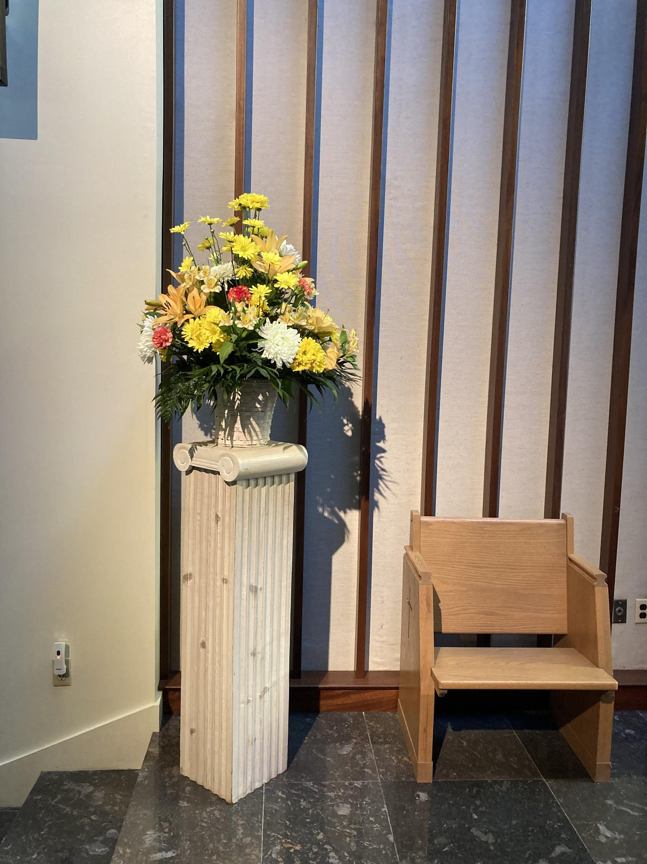
You are welcome to add additional arrangements in front of the two podiums and/or on either side of the altar. (The one thing we ask is that you don’t place a large arrangement in front of the altar – that way everyone can see what’s happening on the altar).
Here is one example.
For urns, another option is to have a circular arrangement that surrounds the urn, such as the one in the picture. The small table we use (not pictured) is 13” (length) x 21” (width) x 24” (height).
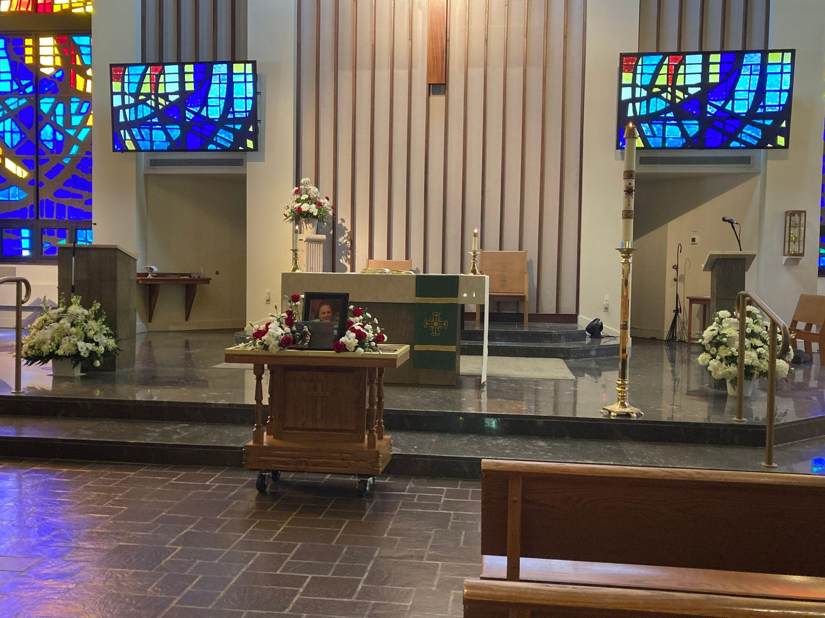

Livestreaming and Recording
Let us know if you would like to livestream the funeral.
The livestream link that you can share with family and friends is:
parish.stnorbert.org/livestream/
If you would like a video recording of the funeral (regardless of whether you are livestreaming), please ask the funeral home.

Pictures, video and memorabilia
The parish is not able to provide technical equipment or support for funeral visitations. Funeral homes are able to provide these services.
Pictures, slideshows, video and memorabilia may be set up by the family and/or the funeral home for the visitation. For the visitation in church, you may have one picture (11”x14” or smaller) beside the urn or casket. We ask that the picture be removed before the funeral begins.

